Module 5 – Wireframes for a Consumer App: Laws Smith

Purpose of the App
This is supposed to be a personal finance app that connects all bank accounts, credit cards, bills, and other spendings as well as budgets in one place. It uses AI to automatically categorize transactions, track spending against budgets in real time, and send proactive push notifications when you are approaching or exceeding a budget. The goal is to help users have real time insight into their spending to help them immediately.

The Scenario
Sarah is out running errands towards the end of the month. She set a budget earlier in the month to help her save for a vacation. Part of the savings are limited spending on clothing and food. On her errands she sees a shirt she likes, checks the app to make sure its still within her monthly spending, sees that it would put her over, and so decides against it. Later she is hungry and because her food budget still has room, buys lunch. Her remaining budget amount is immediately pushed to her phone as soon as the credit card transaction goes through.

Wireframes
- Sarah enters the store and opens her app to just get a general sense of where her finances are. At a glance she can see upcoming bills, where some of her budgets are, but underspent and overspent, as well as quick selections to enter various features of the app.
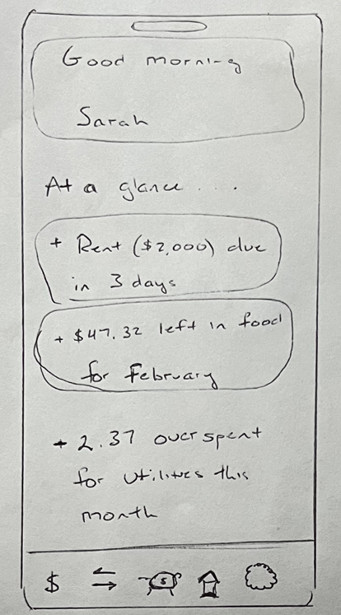
- Sarah looks at a shirt she likes for $36.00. She checks her clothing budget and realizes she only has $15.33 left in her February budget, and thus decides to return the shirt.
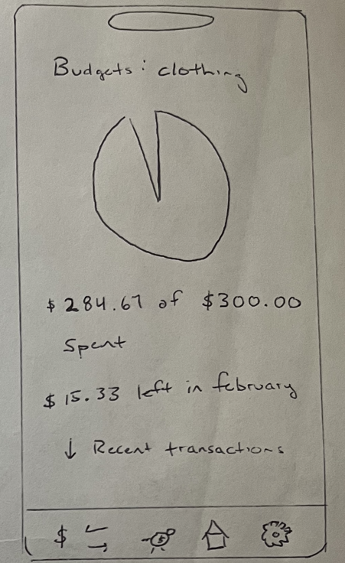
- Sarah gets hungry, so she looks at her food budget and confirms she has $47.32 left for food this month.
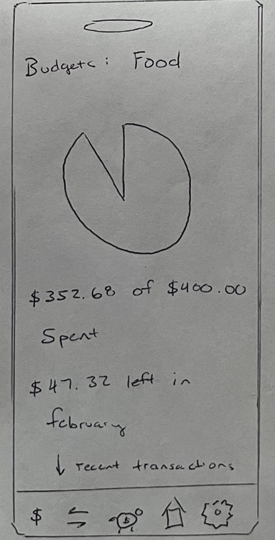
- Sarah buys lunch for $21.63 and immediately gets a push notification that her lunch has been accounted for, leaving $25.69 left for the month.
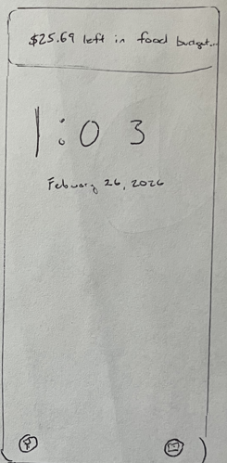
- Just to confirm, Sarah checks her food budget and sees that she does indeed have $25.69 left for the month and can see the recent lunch purchase as well.

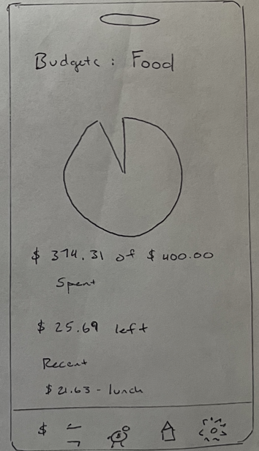

Why This Design is Better
Most budgeting tools only show you how you are doing once you input all the data in and after the fact. Secondly, bank statements just show you spending, but not how you are saving. This app combines them and allows you to stay up to date when making financial decisions. It also removes the tedious part of budgeting: putting in the transactions, and frees up time and mental energy for users to go about their day confident they are achieving their financial goals.

